Intelligent CPU Scheduler Simulator
CA 2 ACADEMIC TASK

Submitted in complete fulfilment of the requirements for the award of degree of
B. Tech CSE
Submitted to
School of Computer Science
Lovely Professional University Phagwara, Punjab


Submitted by: Khushi Kumari, 12310179

Definition of an Operating System
An operating system (OS) is a fundamental software layer that acts as a bridge between users or applications and computer hardware. Managing a computer's hardware resources, including the CPU, memory, storage, and peripherals, as well as offering crucial services to software programs, are its main responsibilities. Users and applications can interact with the system effectively without having to learn low-level hardware details due to the operating system's abstraction of hardware complexity.

Primary Purpose of an Operating System (OS)
An operating system acts as a bridge between users/applications and computer hardware, ensuring efficient, secure, and user-friendly interaction. Its key objectives include:
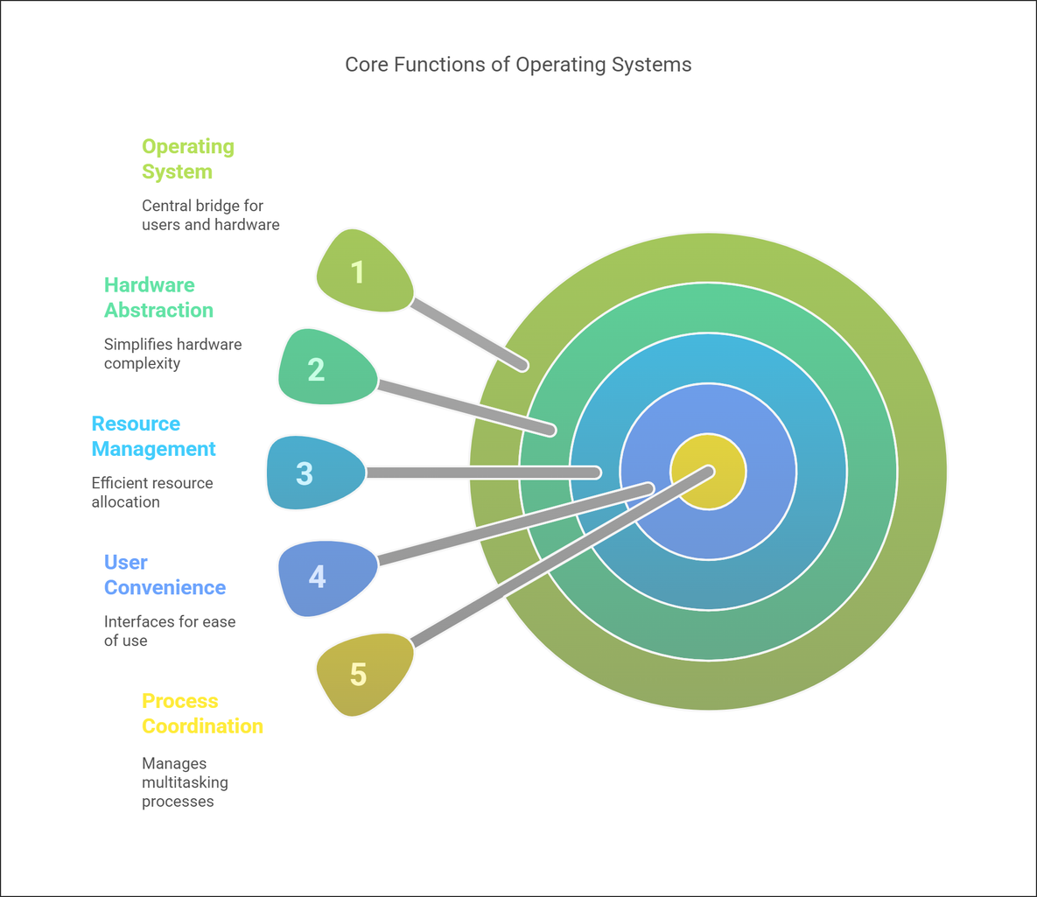

1. Hardware Abstraction
- Hides hardware complexity behind simplified interfaces.
- Manages memory, CPU, and I/O devices, enabling seamless interaction without hardware expertise.
2. Resource Management
- Allocates and schedules hardware resources efficiently.
- Manages CPU time, memory, storage, and peripherals to prevent conflicts and ensure optimal utilization.
3. User Convenience
- Provides graphical and command-line interfaces for ease of use.
- Enables users to execute programs, manage files, and configure settings effortlessly.
4. Process Coordination
- Supports multitasking by managing active processes.
- Handles process creation, termination, synchronization, and inter-process communication.
5. Security & Protection
- Controls access to system resources.
- Safeguards data integrity and prevents unauthorized access, malware, and user errors.
6. Error Handling & Stability
- Detects and resolves hardware/software errors.
- Prevents system crashes and ensures reliable system operation.
7. Standardization
- Provides a consistent platform for software development.
- Ensures applications run across different hardware configurations without modification.

Why Do We Need an Operating System?
An operating system (OS) is essential for managing computer hardware and providing a user-friendly interface. It simplifies system interaction and ensures efficient, secure, and reliable operation. The key reasons for needing an OS include:
1. Hardware Management & Abstraction
- Hides the complexity of hardware operations from users and applications.
- Manages CPU, memory, storage, and I/O devices, allowing seamless interaction without hardware expertise.
2. Efficient Resource Utilization
- Allocates system resources like CPU time, RAM, and disk space efficiently.
- Ensures fair and optimal resource distribution among multiple applications and users.
3. Multitasking & Process Management
- Enables multiple programs to run simultaneously without conflicts.
- Manages process creation, execution, termination, and synchronization.
4. User-Friendly Interface
- Provides graphical (GUI) and command-line (CLI) interfaces for easy interaction.
- Simplifies file management, application execution, and system configuration.
5. Security & Protection
- Controls access to system resources, protecting against unauthorized use.
- Defends against malware, cyber threats, and accidental data corruption.
6. Stability & Error Handling
- Detects and resolves software/hardware errors to prevent system crashes.
- Ensures system reliability and continuous operation.
7. Standardization & Compatibility
- Provides a common platform for software development.
- Allows applications to run on different hardware configurations without modification.

Types of Operating Systems
1. Batch Operating System
- Executes a batch of jobs without user interaction.
- Used in early computing systems for automating repetitive tasks.
- Example: IBM OS/360.
2. Time-Sharing (Multitasking) OS
- Allows multiple users to access a system simultaneously.
- Allocates CPU time in small time slices to each process.
- Example: UNIX, Linux, Windows.
3. Distributed Operating System
- Manages a group of networked computers as a single system.
- Enhances resource sharing, reliability, and efficiency.
- Example: Google’s Fuchsia, Amoeba.
4. Real-Time Operating System (RTOS)
- Processes tasks with strict timing constraints.
- Used in embedded systems, robotics, and critical applications.
- Example: VxWorks, QNX, FreeRTOS.
5. Network Operating System (NOS)
- Provides networking capabilities to manage data, users, and applications across a network.
- Used in servers for centralized control and resource sharing.
- Example: Windows Server, Novell NetWare.
6. Mobile Operating System
- Designed for smartphones, tablets, and other mobile devices.
- Optimized for touch input, power efficiency, and mobile hardware.
- Example: Android, iOS.
7. Embedded Operating System
- Specifically designed for embedded devices with limited resources.
- Found in appliances, automotive systems, and IoT devices.
- Example: Embedded Linux, FreeRTOS.

Advantages and Disadvantages of Operating Systems

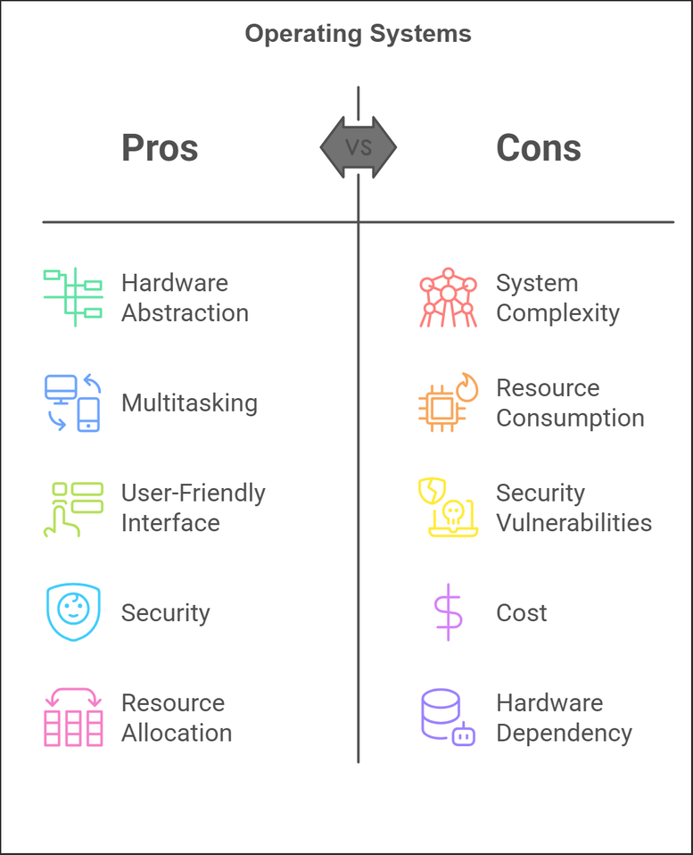

About

An Intelligent CPU Scheduler is an advanced system that optimizes the management of CPU resources in a computing environment by using advanced algorithms and machine learning techniques to intelligently prioritize and allocate tasks, ensuring efficient processing, reduced latency, and improved overall system performance. Unlike traditional schedulers, this innovative solution adapts dynamically to workload patterns and system demands, enabling it to handle complex operations with speed and precision. The Intelligent CPU Scheduler is necessary for increasing device productivity, reducing energy consumption, and providing an uninterrupted user experience, especially in high-performance and multitasking environments. Due to its rapid decision-making capabilities, it is an essential component of the next generation of computational technologies.

THE CRITERIA OF CPU SCHEDULING

CPU scheduling is a crucial aspect of operating system design, and several criteria are considered when evaluating different scheduling algorithms. These criteria help in assessing the performance and effectiveness of a scheduling algorithm in managing the CPU resources efficiently.

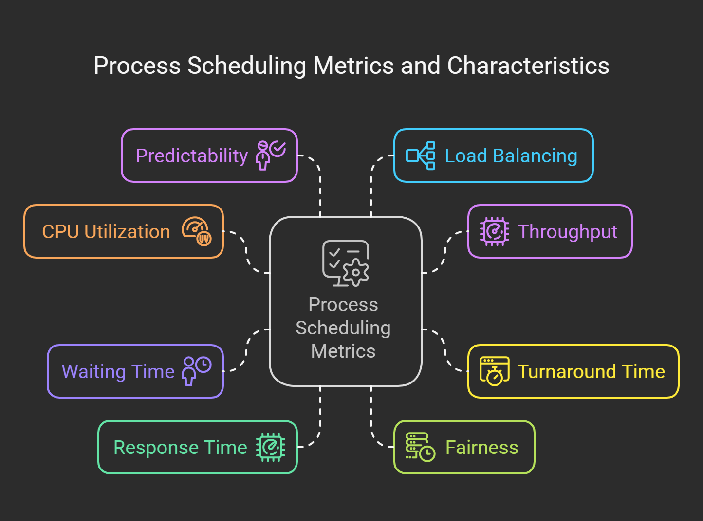

1. CPU Utilization
- Definition: Percentage of time the CPU actively executes processes (not idle).
- Technical Insight:
  - Ideal: Close to 100% in batch systems; varies for interactive systems (e.g., 70–90%).
  - Overhead: High utilization minimizes context-switching time.
  - Algorithms: Shortest Job Next (SJN) maximizes utilization for batch jobs but struggles with I/O-bound processes.
- Real-World Impact: Poor utilization wastes resources. For instance, in First-Come-First-Served (FCFS), long CPU-bound processes may starve I/O-bound tasks, leading to CPU idle time.

2. Throughput
- Definition: Number of processes completed per unit time (e.g., processes/second).
- Technical Insight:
  - Algorithm Dependency: Round Robin (RR) with small time quanta maximizes throughput, but too small quanta increase overhead.
  - Bottlenecks: Throughput drops when processes frequently block for I/O.
- Example:
  - RR with a 10ms quantum achieves 50 processes/second.
  - FCFS with long jobs might drop to 5 processes/second.

3. Turnaround Time
- Definition: Total time from process submission to completion.
Formula: Turnaround Time = Completion Time − Arrival Time
- Technical Insight:
  - Optimal: Shortest Job First (SJF) minimizes average turnaround time but requires accurate burst-time estimates, which are unrealistic in practice.
  - Starvation: Long processes suffer in SJF; Multilevel Queues help by using priority tiers.
- Use Case: Essential in batch systems like payroll processing where speed matters.

4. Waiting Time
- Definition: Time spent in the ready queue (excluding execution/I/O).
Formula: Waiting Time = Turnaround Time − Burst Time
- Technical Insight:
  - Pre-emptive SJF (SRTF) minimizes waiting time for short jobs.
  - Trade-off: Lower waiting for short jobs may increase waiting for long jobs (Convoy Effect in FCFS).
  - Measurement: Critical for user-centric systems; 30ms wait in RR feels instantaneous, but 500ms in FCFS impacts user experience.

5. Response Time
- Definition: Time from process submission to the first CPU allocation (important for interactive systems).
- Technical Insight:
  - Interactive Systems: RR with small time slices (10–100ms) ensures low response times.
  - Worst-case scenario: In FCFS, long-running processes can delay subsequent tasks indefinitely.
  - Real-Time Systems: Enforced response times (e.g., Rate-Monotonic Scheduling in Robotics Control).

6. Fairness
- Definition: Equitable CPU time allocation across processes.
- Technical Insight:
  - Preventing Starvation: Algorithms like Priority Scheduling use aging (increase priority of waiting processes).
  - Fairness Metrics: Measured using Jain’s Fairness Index or waiting time variance.
- Example: Linux’s Completely Fair Scheduler (CFS) balances fairness and throughput via "virtual runtime."

7. Predictability
- Definition: Consistency in scheduling behavior.
- Technical Insight:
  - Real-Time Systems: Deadline Scheduling guarantees process completion before deadlines (e.g., aviation systems).
  - Variance: High predictability minimizes jitter (e.g., media streaming).
  - Trade-off: Predictability often conflicts with flexibility. Algorithms like Earliest Deadline First (EDF) excel here.

8. Load Balancing
- Definition: Distribution of CPU workload across processes/cores.
- Technical Insight:
  - Multi-Core Systems: Symmetric Multi-Processing (SMP) uses per-CPU run queues and work-stealing (e.g., Linux CFS).
  - Heterogeneous Systems: Big.LITTLE architectures (ARM) assign tasks to high/low-power cores based on load.
  - Dynamic Adjustment: Load balancers migrate processes between cores to avoid hotspots (critical in data centers).

CPU SCHEDULING TECHNIQUES

CPU scheduling is one of the most crucial components of contemporary operating systems. It defines which processes will be executed on the CPU and the order, optimizing CPU time, compute and systems responsiveness and minimizing waiting, ending, and feedback times. This article summarizes all CPU scheduling techniques, including the algorithms, the factors to consider, and the implementation methods.

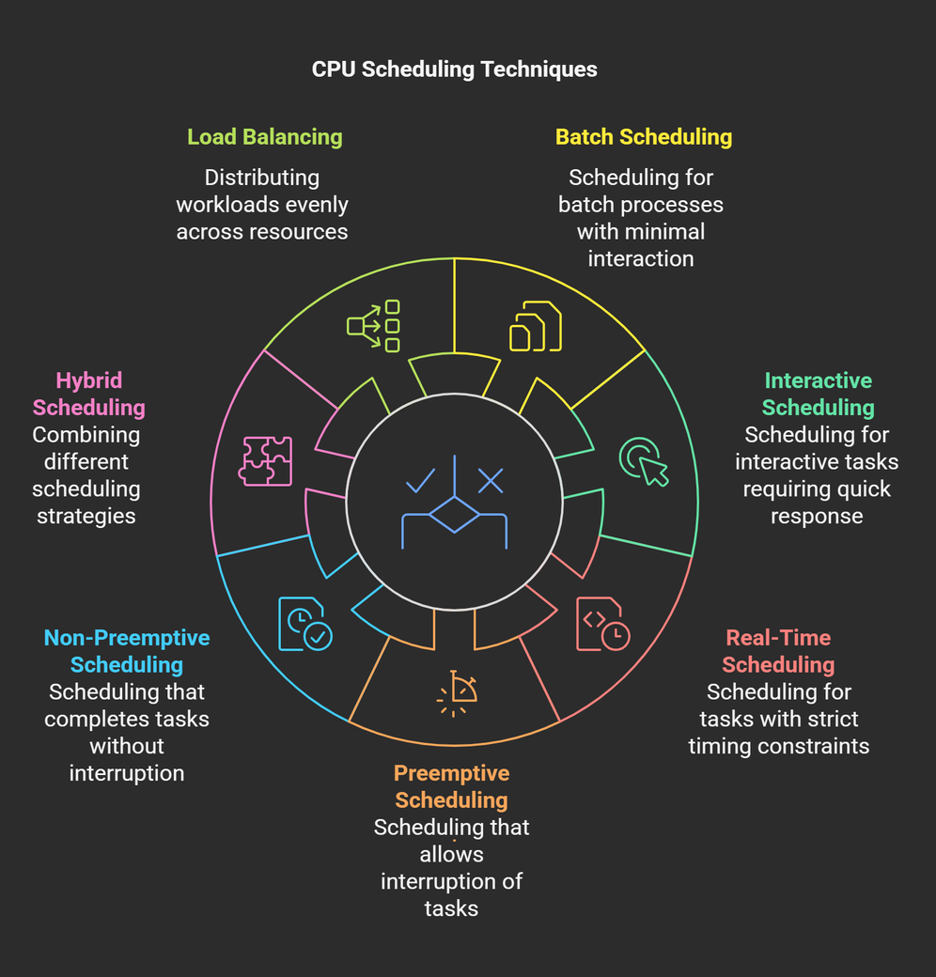

1. Batch Scheduling
This approach is suited for environments where jobs are grouped and executed with minimal user interaction.
- First-Come, First-Served (FCFS):
  - The simplest scheduling algorithm where processes are executed in the order they arrive in the queue.
  - Advantages: Easy to implement; no starvation.
  - Disadvantages: Poor average waiting time (convoy effect when a long process delays shorter ones).
- Shortest Job Next (SJN):
  - Selects processes with the shortest estimated execution time.
  - Advantages: Minimizes average waiting time.
  - Disadvantages: It requires prior knowledge of execution time and risks starvation for longer processes.

2. Interactive Scheduling
Designed for multi-user systems requiring quick responses to user actions.
- Round Robin (RR):
  - Each process is assigned a fixed time slice (quantum). If a process does not finish in its quantum, it moves to the back of the queue.
  - Advantages: Ensures fairness and responsiveness.
  - Disadvantages: Performance heavily depends on the quantum size.
- Priority Scheduling:
  - Processes are assigned a priority, and the CPU is allocated to the highest-priority process.
  - Advantages: Flexibility to prioritize urgent tasks.
  - Disadvantages: Risk of starvation for low-priority processes; mitigated by aging (increasing priority over time).

3. Real-Time Scheduling
Specifically designed for real-time systems where timing constraints are critical.
- Earliest Deadline First (EDF):
  - Dynamically prioritizes processes based on their deadlines. The process with the nearest deadline is executed first.
  - Advantages: Optimal for meeting deadlines.
  - Disadvantages: Computational overhead in maintaining sorted deadlines.
- Rate-Monotonic Scheduling:
  - Assign static priorities based on the process's period (shorter periods get higher priority).
  - Advantages: Simple and effective for periodic tasks.
  - Disadvantages: May fail to meet all deadlines under certain conditions.

4. Pre-emptive Scheduling
Allows the CPU to reallocate from a running process to a higher-priority process mid-execution.
- Shortest Remaining Time (SRT):
  - The pre-emptive version of SJN, where the CPU switches to the process with the shortest remaining time.
  - Advantages: Reduces overall waiting time.
  - Disadvantages: High context-switching overhead; starvation is possible.
- Pre-emptive Priority Scheduling:
  - The CPU is reallocated whenever a higher-priority process arrives.
  - Advantages: Guarantees immediate attention to critical tasks.
  - Disadvantages: Susceptible to starvation without aging.

5. Non-Pre-emptive Scheduling
Processes run to completion once allocated the CPU.
- First-Come, First-Served (FCFS):
  - Same as in batch scheduling but with no pre-emption.
- Non-Pre-emptive Priority Scheduling:
  - Similar to priority scheduling, processes cannot be interrupted.

6. Hybrid Scheduling
Combines features of multiple techniques to balance efficiency and responsiveness.
- Multilevel Queue Scheduling:
  - Divide processes into separate queues based on priority or type (e.g., batch, interactive). Each queue has its scheduling algorithm.
  - Advantages: Tailored to process categories; efficient handling.
  - Disadvantages: Complex implementation; inter-queue scheduling overhead.
- Multilevel Feedback Queue Scheduling:
  - Processes can move between queues based on their behavior and requirements.
  - Advantages: Adapts to dynamic system needs; reduces starvation.
  - Disadvantages: High complexity in managing queues and transitions.

7. Load Balancing
Vital for multiprocessor systems to ensure optimal resource utilization.
- Static Load Balancing:
  - Allocates tasks to processors at the start based on predefined rules.
  - Advantages: Simple and predictable.
  - Disadvantages: Cannot adapt to runtime conditions.
- Dynamic Load Balancing:
  - Continuously monitors system load and redistributes tasks as needed.
  - Advantages: Efficient resource use; adapts to workload changes.
  - Disadvantages: Communication overhead and complexity

Factors Influencing CPU Scheduling

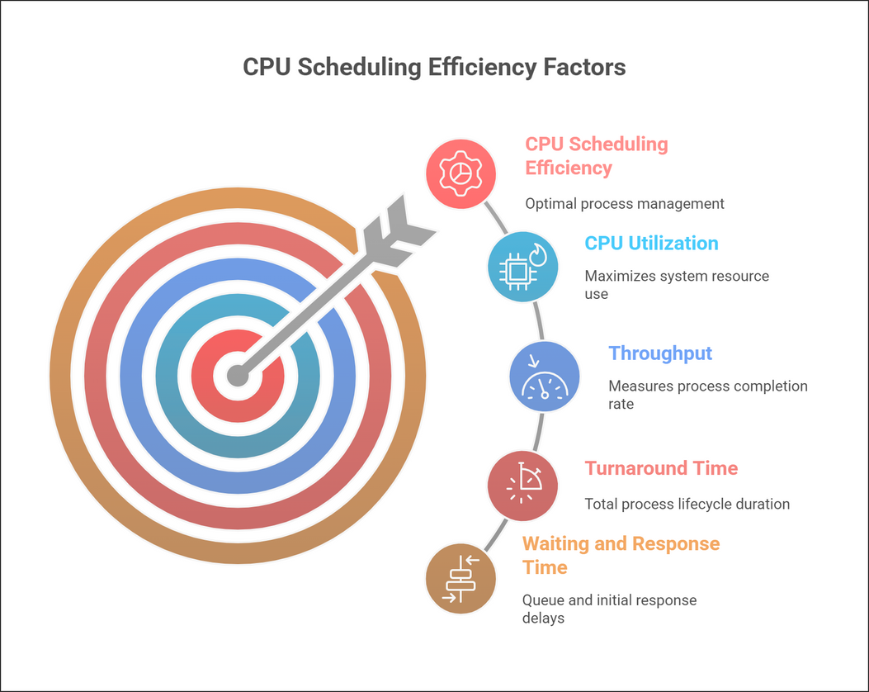

- CPU Utilization
  - Keep the CPU busy to maximize productivity.
- Throughput
  - Complete as many tasks as possible in a given time.
- Turnaround Time
  - Reduce the total time a task takes from start to finish.
- Waiting Time
  - Minimize how long tasks wait in line before execution.
- Response Time
  - Ensure quick initial reactions to user requests.

Implementation Considerations
- Context Switching: Efficient mechanisms are essential to minimize overhead during process transitions.
- Starvation Handling: Techniques like aging mitigate issues where low-priority processes are indefinitely delayed.
- Performance Metrics: Regularly evaluate scheduling based on turnaround time, waiting time, and responsiveness.

Key Concepts in CPU Scheduling

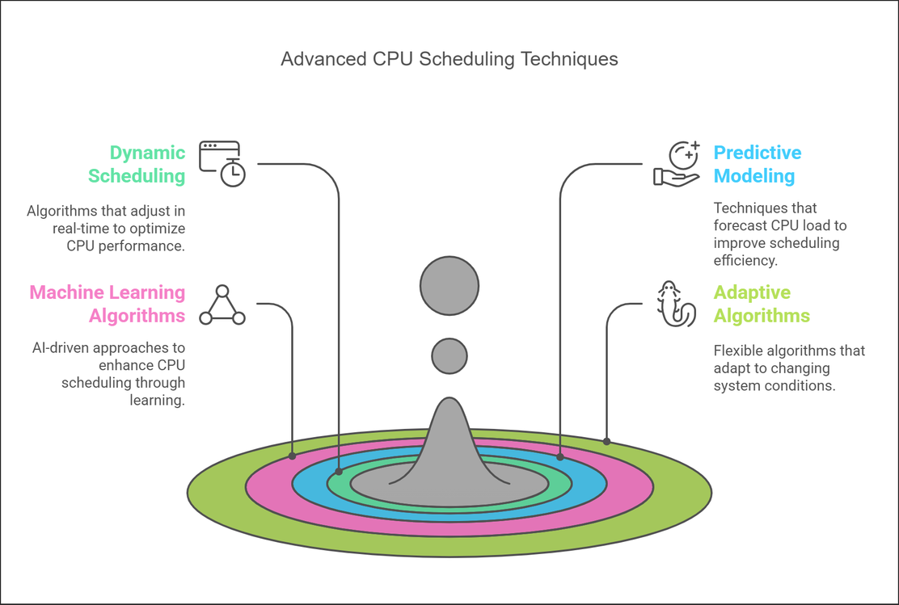

Dynamic Scheduling Algorithms
Adapt in real time, reallocating CPU resources based on workload and priorities.
Key Features:
- Adjusts dynamically to the system state.
- Flexible for unpredictable workloads.
Examples:
- Dynamic Priority Scheduling: Adjusts priorities (e.g., aging).
- Fair-Share Scheduling: Balances resources among users/groups.
Pros: Efficient resource use; prevents starvation.
Cons: Higher overhead, possible delays.

Predictive Modelling
Uses historical data to forecast CPU usage for proactive scheduling.
How It Works:
- Analyse past execution times, arrival patterns, and resource demands.
- Uses statistical or ML models to predict CPU needs.
- Optimizes scheduling based on forecasts.
Applications:
- Used in cloud computing and real-time systems.
- Prevents bottlenecks by pre-emptive CPU allocation.
Pros: Faster scheduling, reduced delays.
Cons: Accuracy depends on data; adds computational overhead.

ML in CPU Scheduling
Machine learning enhances scheduling by learning from past data to optimize decisions.
Key Approaches:
- Supervised Learning: Predicts scheduling parameters using labelled data.
- Reinforcement Learning: Adapts strategies based on feedback.
Examples:
- Neural Networks: Predict runtimes and deadlines.
- Reinforcement Learning: Adjusts scheduling dynamically.
- SVM: Classifies processes and assigns priorities.
Pros: Self-improving, adaptable, reduces manual tuning.
Cons: High computational cost, data-dependent, integration challenges.

Adaptive Algorithms in CPU Scheduling
Modify behavior based on system changes to maintain optimal performance.
How They Work:
- Monitor CPU load, queue length, and response times.
- Adjust scheduling parameters dynamically.
- Balance CPU allocation for efficiency.
Types:
- Load-aware: Distributes workload across processors.
- Priority-based: Adjusts process priority as needed.
Examples:
- MLFQ: Moves processes across queues based on runtime.
- Feedback-Controlled Scheduling: Uses feedback loops for adjustments.
Pros: Responsive, fair, improves throughput.
Cons: Complex design, stability challenges.

Applications in Operating Systems:

1. Real-Time Scheduling
Real-time scheduling is critical in systems where strict timing constraints are paramount, such as embedded systems, medical devices, or avionics.
- Key Characteristics:
  - Hard Real-Time Systems: Deadlines are strict, and missing them could lead to catastrophic consequences (e.g., pacemakers, and industrial robots).
  - Soft Real-Time Systems: Deadlines are important, but occasional misses are tolerable (e.g., video streaming, gaming).
- Applications:
  - Simulation and Optimization: Algorithms like Earliest Deadline First (EDF) and Rate-Monotonic Scheduling are simulated to ensure they meet timing constraints under varying workloads.
  - Event-Driven Tasks: Real-time systems prioritize events triggered by external factors (e.g., sensors in autonomous vehicles).
- Challenges:
  - Managing deadlines and task priorities dynamically.
  - Balancing resource allocation without introducing delays or jitter.
- Examples:
  - Automotive systems use real-time scheduling to coordinate sensors and actuators.
  - Medical devices like ventilators or MRI machines rely on precise task execution.

2. Multicore Systems
With the rise of multicore processors, efficient CPU scheduling is essential to leverage parallelism and optimize performance.
- Key Features:
  - Parallel Processing: Distributes tasks across multiple cores to enhance throughput and minimize execution time.
  - Cache Optimization: Schedulers attempt to keep related processes on the same core to maximize cache efficiency.
- Applications:
  - Thread Scheduling: Distributes threads of multithreaded applications (e.g., web servers, simulations) across cores for balanced performance.
  - Affinity Scheduling: Techniques like processor affinity bind processes to specific cores, reducing overhead from frequent context switches.
  - Load Balancing: Dynamically redistributes tasks among cores to avoid overloading any single processor.
- Challenges:
  - Synchronizing shared resources among cores.
  - Managing communication overhead between cores.
- Examples:
  - Operating systems like Linux and Windows use multicore-aware schedulers (e.g., Completely Fair Scheduler in Linux).
  - High-performance computing (HPC) leverages multicore systems for simulations and data analysis.

3. Energy-Efficient Scheduling
Energy efficiency is a critical goal in modern computing, particularly in mobile devices, data centres, and IoT systems.
- Key Concepts:
  - Dynamic Voltage and Frequency Scaling (DVFS): Adjusts CPU voltage and frequency based on workload, reducing energy consumption during low activity.
  - Idle Core Management: Puts unused cores into sleep states to conserve power.
  - Thermal Management: Prevents overheating by modulating CPU performance.
- Applications:
  - Power-Aware Scheduling: Balances energy consumption with performance needs by scaling CPU resources adaptively.
  - Green Data Centres: Implements scheduling policies to minimize power usage while handling server workloads efficiently.
- Challenges:
  - Ensuring performance doesn’t degrade significantly while saving energy.
  - Adapting to workloads that fluctuate unpredictably.
- Examples:
  - Mobile operating systems (e.g., Android, iOS) use energy-efficient scheduling for prolonged battery life.
  - Cloud providers like AWS and Google Cloud integrate energy-aware scheduling in their data centres.

4. Hybrid Scheduling
Hybrid scheduling blends multiple algorithms to cater to diverse workload characteristics, achieving efficiency and fairness.
- Key Features:
  - Adaptive Approaches: Combines pre-emptive and non-pre-emptive techniques based on workload demands.
  - Queue Hierarchies: Implements multilevel queues where each level may use different algorithms (e.g., FCFS for background processes, RR for interactive tasks).
- Applications:
  - Workload Adaptation: Adjusts to varying workloads by using appropriate scheduling policies. For instance:
    - Real-time tasks → EDF or Rate-Monotonic.
    - Interactive tasks → Round Robin or Multilevel Feedback Queue.
  - Fair Resource Distribution: Prevents starvation by ensuring equitable CPU access for all processes.
- Challenges:
  - Managing the complexity of combining and transitioning between algorithms.
  - Balancing performance metrics like turnaround time, fairness, and responsiveness.
- Examples:
  - Modern OS kernels (e.g., Linux) incorporate hybrid scheduling for desktop, server, and embedded environments.
  - Data centres use hybrid approaches to handle real-time analytics, background tasks, and user queries simultaneously.

Advantages of Intelligent CPU Scheduler Simulators

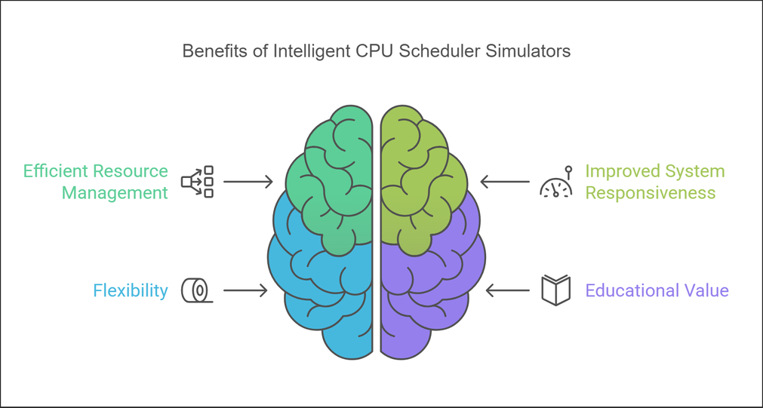

1. Efficient Resource Management
One of the primary advantages of intelligent CPU scheduler simulators is their ability to optimize the allocation and usage of CPU resources, ensuring that every process gets adequate CPU time while avoiding resource wastage.
- How It Works:
  - Simulators model real-world scenarios and test scheduling strategies to find the most efficient approach for a given workload.
  - Bottlenecks, such as processes waiting too long in queues, are identified and mitigated through optimized algorithms.
- Applications:
  - Improving CPU utilization in multitasking environments where processes compete for limited resources.
  - Identifying scheduling inefficiencies that lead to resource underutilization or overloading.
- Benefits:
  - Reduced idle CPU time, maximizing system performance.
  - Minimization of unnecessary context switches, which consume valuable CPU cycles.
- Example Use Case:
  - In data centres, intelligent simulators can help balance workloads across servers, improving operational efficiency.

2. Improved System Responsiveness
By simulating various scheduling strategies, these tools enhance the operating system’s responsiveness, ensuring that tasks requiring immediate attention are executed promptly.
- Key Features:
  - Simulators allow testing under various conditions, such as different process arrival rates, priorities, and workloads.
  - Real-time performance metrics are monitored, enabling fine-tuning of algorithms to reduce response times.
- Applications:
  - Systems where user interaction is critical, such as interactive desktop environments or gaming consoles.
  - Real-time applications where quick response to external events, such as sensor inputs, is essential.
- Advantages:
  - Faster task execution, minimizing user-perceived latency.
  - Increased system reliability, as potential delays in handling critical tasks are eliminated.
- Real-World Example:
  - In healthcare systems, simulators help fine-tune scheduling for critical applications like patient monitoring, where delays could have life-threatening consequences.

3. Flexibility
Intelligent CPU scheduler simulators provide a highly adaptable testing environment, enabling the evaluation and customization of different algorithms.
- Key Attributes:
  - Support for a wide range of scheduling algorithms, such as FCFS, SJN, RR, EDF, and hybrid models.
  - Capability to simulate diverse workload conditions, including peak loads and fluctuating demands.
  - Customizable settings to test how algorithms respond to specific constraints, like real-time deadlines or energy efficiency.
- Benefits:
  - Facilitates algorithm comparisons to determine the best fit for a specific use case.
  - Enables developers to tweak algorithm parameters, such as time quantum or priority levels, to optimize for performance or fairness.
- Applications:
  - Designing scheduling policies for new operating systems or embedded devices.
  - Adapting existing algorithms to unique scenarios, such as IoT devices or cloud-based platforms.
- Example Scenario:
  - In distributed systems, simulators help developers evaluate load-balancing algorithms that adapt to varying network conditions.

4. Educational Value
Intelligent simulators are excellent tools for learning and experimentation, making them valuable for students, educators, and professionals.
- Learning Opportunities:
  - Students can interactively explore the behavior of different scheduling algorithms, understanding their strengths and weaknesses.
  - Simulators offer insights into complex concepts like context switching, waiting time, and resource contention.
- Key Features:
  - Visual representations of process execution, queue behavior, and CPU utilization.
  - Step-by-step simulation of how scheduling decisions are made and their impact on system performance.
- Advantages:
  - Provides hands-on experience in a risk-free environment, as experiments do not impact actual systems.
  - Encourages innovative thinking by allowing users to create and test their custom scheduling techniques.
- Applications:
  - Academic courses on operating systems, where students can visualize and analyse scheduling processes.
  - Professional training programs to enhance understanding of performance optimization in real-world systems.
- Example Tool:
  - Tools like the GNU Scheduling Simulator (GSS) or custom-built simulators in academic settings allow learners to experiment with algorithms in an interactive way.

Challenges and Limitations

1. Complexity
As systems grow more advanced and interconnected, the process of simulating and implementing CPU scheduling algorithms becomes increasingly intricate.
- Reasons for Complexity:
  - Diverse Workloads: Modern systems handle a mix of batch, interactive, and real-time processes, each requiring distinct scheduling strategies.
  - Multiprocessing Environments: Scheduling in multicore and distributed systems introduces interdependencies among processors.
  - Dynamic Behavior: Processes may behave unpredictably, altering their execution patterns due to user interaction or external events.
- Challenges:
  - Simulating these scenarios requires significant computational resources to account for variations in system states and workloads.
  - Developing algorithms that balance competing priorities (e.g., throughput, fairness, and energy efficiency) increases complexity.
- Impacts:
  - Higher computational costs during simulation and implementation.
  - Increased difficulty in achieving consistent performance across diverse scenarios.

2. Parameter Sensitivity
Scheduling algorithms often depend on various parameters (e.g., time quantum in Round Robin, priority weights in Priority Scheduling) that significantly influence their performance.
- Challenges:
  - Identifying Optimal Parameters:
    - For some algorithms, performance can degrade drastically if parameters are not set correctly. For instance, an excessively small time quantum in Round Robin leads to frequent context switches, while a large quantum increases response time.
  - System Variability:
    - Parameters optimal in one scenario may fail under different conditions, such as peak loads or priority shifts.
- Addressing the Issue:
  - Tools like simulators can help test multiple configurations, but they often rely on trial and error, consuming time and resources.
  - Machine learning models are sometimes employed to predict optimal parameters based on historical data, though this adds computational complexity.
- Consequences:
  - Suboptimal parameter settings can result in increased waiting times, lower throughput, and unbalanced resource allocation.

3. Real-Time Adaptation
The dynamic nature of real-world systems presents significant challenges in ensuring real-time responsiveness.
- Key Requirements:
  - Scheduling algorithms must adapt swiftly to changes in workloads, such as sudden surges in process arrivals or priority shifts.
  - Real-time systems often require strict adherence to deadlines, adding to the complexity of adaptation.
- Challenges in Implementation:
  - Monitoring Overhead:
    - Real-time monitoring of system conditions and workloads can consume significant CPU resources, potentially offsetting the benefits of adaptive scheduling.
  - Latency Issues:
    - Delays in adapting to changes, such as switching algorithms or recalculating priorities, can degrade performance.
- Examples of Difficulties:
  - In environments like cloud computing, workloads can change unpredictably, making it hard to balance load distribution in real-time.
  - Embedded systems with limited resources (e.g., sensors) must maintain strict timing constraints without overloading the CPU.
- Consequences:
  - Failure to adapt effectively can lead to missed deadlines, poor system responsiveness, and user dissatisfaction.

4. Algorithm Limitations
Not all scheduling algorithms are suited for every workload or system configuration, leading to challenges in achieving optimal performance.
- Limitations:
  - Scenario-Specific Efficiency:
    - Algorithms like Shortest Job Next (SJN) are efficient for batch processing but fail in interactive systems due to their inability to handle priority shifts dynamically.
    - Rate-Monotonic Scheduling works well in fixed-priority real-time systems but may be inefficient for variable workloads.
  - Starvation Risks:
    - Algorithms like Priority Scheduling can lead to starvation for low-priority processes unless mechanisms like aging are implemented.
  - Overhead Concerns:
    - Highly dynamic algorithms, such as those relying on frequent context switching or real-time parameter adjustment, introduce significant overhead.
- Impact on Systems:
  - Suboptimal algorithm selection can result in inefficiencies, such as underutilized CPU resources, prolonged waiting times, or even system instability.
- Examples:
  - Real-time systems may suffer deadline violations when using algorithms not designed to handle hard real-time constraints.
  - Multicore systems may experience imbalanced core utilization if scheduling algorithms are not designed to account for inter-core dependencies.

Proposed Work
Working of Project

Round Robin -
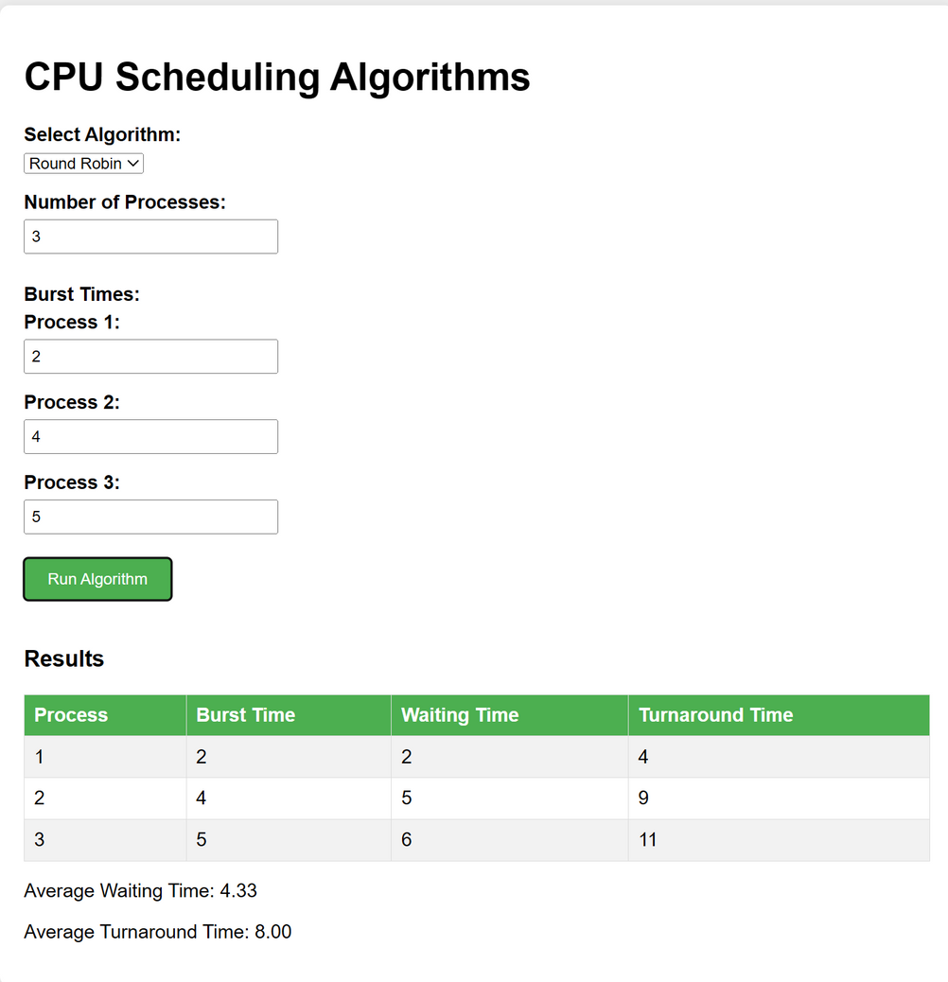

First come, First Serve -
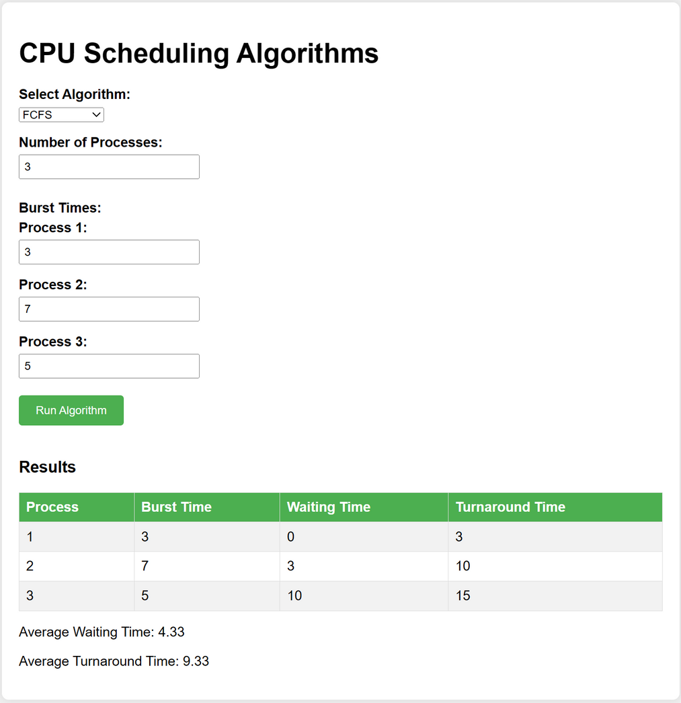

Shortest Job first -
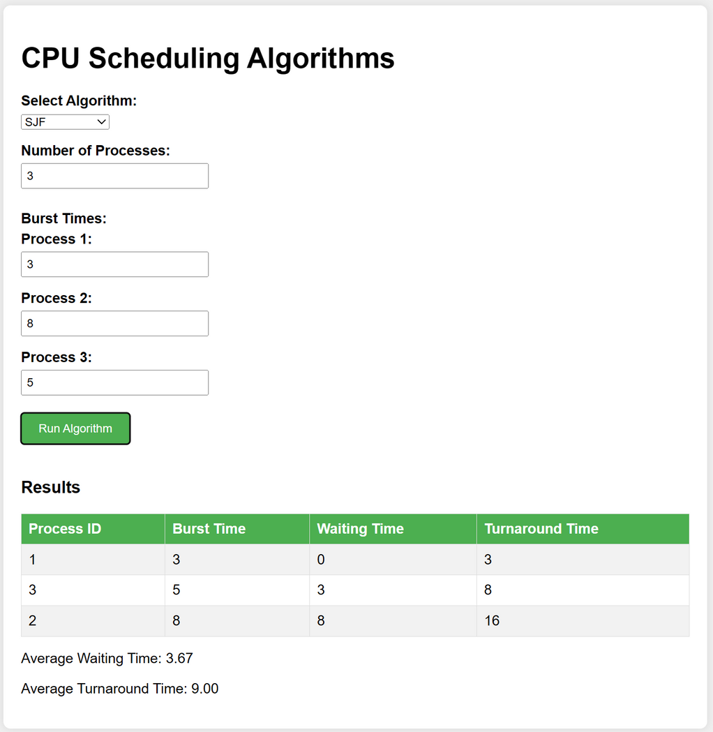

Future Directions

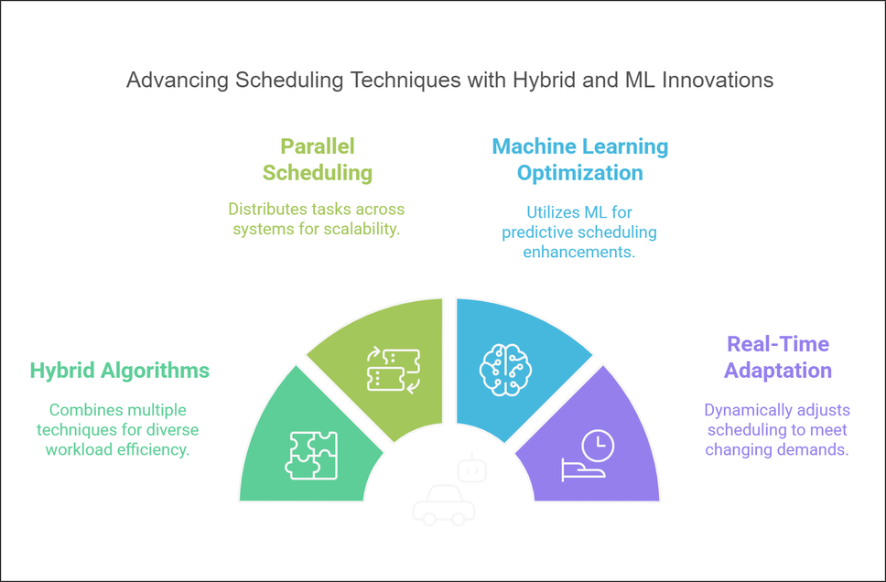

1. Hybrid Scheduling Algorithms
Hybrid scheduling aims to combine the strengths of various scheduling techniques, overcoming the limitations of individual methods and ensuring efficient and versatile scheduling.
- Concept:
  - Uses a blend of preemptive and non-preemptive strategies or integrates algorithms like Round Robin, Priority Scheduling, and Multilevel Feedback Queue.
  - Dynamically switches between algorithms based on system needs, such as workload type or process priority.
- Advantages:
  - Enhanced Flexibility: Adapts to diverse workloads, such as a mix of batch and real-time processes.
  - Improved Fairness: Prevents starvation by balancing priorities across all processes.
  - Optimized Performance: Leverages the best-suited algorithm for the task at hand, improving responsiveness and throughput.
- Challenges:
  - Complex Implementation: Requires intricate mechanisms to manage transitions between algorithms.
  - Overhead: Monitoring and decision-making can increase computational costs.
- Applications:
  - Modern operating systems where multitasking is critical, such as desktops, smartphones, and servers.
  - Cloud computing environments where workloads are dynamic and unpredictable.
- Example:
  - Multilevel Feedback Queue (MLFQ) scheduling is a popular hybrid approach where processes move between queues based on behavior.

2. Parallel and Distributed Scheduling
As systems become increasingly multicore and distributed, parallel and distributed scheduling techniques are essential to ensure scalability and efficient resource utilization.
- Concept:
  - Parallel Scheduling: Distributes processes across multiple CPU cores in a single system.
  - Distributed Scheduling: Balances tasks across multiple interconnected systems in a distributed environment.
- Advantages:
  - Enhanced Scalability: Efficiently handles growing workloads by leveraging multiple cores or systems.
  - Improved Performance: Reduces process waiting times and increases throughput by parallel execution.
  - Resource Optimization: Ensures balanced resource utilization across cores or nodes.
- Challenges:
  - Synchronization Issues: Requires mechanisms to manage dependencies and shared resources.
  - Communication Overhead: Distributed systems must handle delays caused by inter-system communication.
  - Load Balancing: Ensuring fair distribution of tasks without overloading any single core or node.
- Applications:
  - High-Performance Computing (HPC) for simulations, modeling, and data analysis.
  - Data centers and cloud environments where workloads are distributed across servers.
- Example:
  - Hadoop’s YARN (Yet Another Resource Negotiator) uses distributed scheduling to manage resources in big data systems.

3. Machine Learning-Based Optimization
Integrating machine learning (ML) techniques into CPU scheduling provides intelligent, data-driven optimization of scheduling decisions.
- Concept:
  - Predictive Analytics: ML models predict process behavior, such as execution time and resource demands, based on historical data.
  - Reinforcement Learning: Algorithms learn optimal scheduling strategies over time by receiving feedback (e.g., rewards for reducing latency).
  - Dynamic Adaptation: Continuously fine-tunes parameters like time quantum, priority levels, and core allocation.
- Advantages:
  - Improved Decision-Making: Uses real-time data to select or adjust algorithms for better efficiency.
  - Enhanced Responsiveness: Dynamically adapts to workload variations without manual intervention.
  - Self-Optimization: Learns and evolves based on past scheduling outcomes, improving over time.
- Challenges:
  - Data Requirements: Requires large volumes of training data for accurate predictions and effective learning.
  - Computational Overhead: Running ML models in real-time can consume significant resources.
  - Complexity: Integration into existing systems requires significant development effort.
- Applications:
  - Cloud platforms for dynamic resource allocation and load balancing.
  - Autonomous systems that need real-time responses, such as drones or self-driving cars.
- Example:
  - Google’s Borg system uses ML-based scheduling to optimize resource allocation in its data centers.

4. Real-Time Adaptation
The demand for real-time adaptation in CPU scheduling is growing as systems must respond to rapidly changing workloads and priorities.
- Concept:
  - Develops adaptive algorithms that continuously monitor system state and make real-time adjustments to scheduling policies.
  - Incorporates feedback loops to optimize CPU allocation dynamically.
- Advantages:
  - Maximized Responsiveness: Ensures high-priority tasks are executed without delay.
  - Enhanced Fairness: Balances competing priorities while maintaining system stability.
  - Improved Performance: Reduces wasted CPU cycles by reallocating resources to where they are most needed.
- Challenges:
  - Monitoring Overhead: Real-time monitoring can strain system resources.
  - Latency: Delays in adaptation could undermine the benefits of real-time scheduling.
  - Algorithm Stability: Maintaining stable performance under rapidly changing conditions is complex.
- Applications:
  - Real-time operating systems (RTOS) in critical systems, such as industrial automation and medical devices.
  - Interactive systems like video games and augmented reality applications that demand low latency.
- Example:
  - Adaptive scheduling in IoT devices ensures efficient operation even with fluctuating workloads and power constraints.

Intelligent CPU Scheduler Simulators are expected to make significant progress in improving operating system performance and efficiency as technology continues to advance. By utilizing advanced algorithms and techniques, researchers and engineers can create innovative solutions to complex scheduling problems. The future of operating system optimization appears extremely promising as new approaches and emerging technologies continue to be explored.

HISTORICAL CONTEXT

Intelligent CPU scheduler simulators emerged from advancements in computer science and engineering, aimed at optimizing CPU scheduling algorithms to improve system performance.
Early Developments:
- First-Come, First-Served (FCFS): One of the earliest and simplest scheduling algorithms, introduced in the mid-20th century, where processes are executed in the order they arrive.
- Shortest Job Next (SJN): Introduced as an improvement over FCFS, SJN schedules processes based on their burst time, reducing average waiting time.
- Round Robin (RR): Designed for time-sharing systems, RR assigns fixed time slices to processes, ensuring fair CPU allocation.
- Priority Scheduling: Introduced to allow processes with higher priorities to execute first, improving system responsiveness for critical tasks.

Advancements in Simulation Techniques:
- Gantt Charts: Visualization tools to represent scheduling algorithms and process execution, aiding in understanding and optimizing scheduling strategies.
- Performance Metrics: Development of metrics like waiting time, turnaround time, and CPU utilization to evaluate and compare scheduling algorithms.

Intelligent Techniques:
- Machine Learning Algorithms: Leveraging data-driven approaches to learn from past scheduling outcomes and improve future scheduling decisions.
- Dynamic Scheduling Algorithms: Adjusting scheduling parameters in real-time based on the system's current state to optimize performance.
- Predictive Modeling: Using historical data and usage patterns to forecast future tasks and optimize scheduling decisions.

Recent Advances:
- Adaptive Algorithms: Developing scheduling algorithms that adapt to changes in system load, priority, and other factors in real-time.
- Energy-Efficient Scheduling: Incorporating power management techniques to balance performance with energy consumption.
- Hybrid Scheduling: Combining multiple scheduling algorithms to provide a more robust and efficient solution.

Future Directions:
- Hybrid and Metaheuristic Approaches: Combining different scheduling techniques to leverage their strengths and overcome their weaknesses.
- Parallel and Distributed Scheduling: Enhancing scalability and performance in complex, large-scale systems.
- Machine Learning-Based Optimization: Integrating machine learning techniques to automatically fine-tune scheduling parameters.
- Real-World Applications: Applying intelligent scheduling simulators to optimize resource management, task scheduling, and system performance in various fields.

As technology continues to advance, the potential of intelligent CPU scheduler simulators is expanding. Future research directions include the development of more powerful and versatile scheduling algorithms, ultimately improving the efficiency and performance of operating systems.

USAGE
Intelligent CPU scheduler simulators have become invaluable in a variety of real-world scenarios due to their ability to optimize CPU scheduling and improve overall system performance.

- Cloud Computing: Optimizing CPU resource allocation in cloud environments to ensure efficient operation of virtual machines and improve response times for cloud services.
- Data Centres: Enhancing the performance and energy efficiency of data centres by simulating and refining CPU scheduling strategies for large-scale server farms.
- Embedded Systems: Improving the real-time performance of embedded systems in automotive, aerospace, and industrial automation applications by optimizing CPU scheduling algorithms.
- High-Performance Computing (HPC): Boosting the efficiency of HPC systems by optimizing process scheduling, leading to faster computation times and better resource utilization.
- Telecommunications: Enhancing the performance of telecommunications networks by optimizing CPU scheduling in network switches and routers to handle high volumes of data traffic.
- Mobile Devices: Optimizing CPU scheduling on mobile devices to balance performance and battery life, ensuring a smooth user experience.
- Internet of Things (IoT): Enhancing the performance of IoT devices and networks by optimizing CPU scheduling to handle a large number of connected devices efficiently.

Intelligent CPU Scheduler Simulators: Real-World Applications
Intelligent CPU scheduler simulators have been widely applied across various domains, leading to significant improvements in system performance and efficiency. Here are some key applications:
Engineering and Design:
- Embedded Systems: Optimizing CPU scheduling in embedded systems to ensure real-time performance in applications such as automotive, aerospace, and industrial automation.
- High-Performance Computing (HPC): Enhancing process scheduling in HPC systems, leading to faster computation times and better resource utilization.
- Telecommunications: Improving the performance of network switches and routers by optimizing CPU scheduling to handle high volumes of data traffic efficiently.
Finance and Economics:
- Financial Modelling: Simulating and optimizing CPU scheduling in financial modelling applications, ensuring timely and accurate computations for risk assessment and decision-making.
- Algorithmic Trading: Enhancing the performance of trading algorithms by optimizing CPU resource allocation, leading to quicker execution of trades and improved profitability.
- Data Analysis: Improving the efficiency of data analysis processes in financial institutions by optimizing CPU scheduling for large-scale data computations.
Medicine and Healthcare:
- Medical Imaging: Optimizing CPU scheduling in medical imaging applications, ensuring real-time processing of X-rays, CT scans, and MRIs for accurate diagnosis and treatment planning.
- Genomic Data Analysis: Enhancing the performance of genomic data analysis by optimizing CPU resource allocation for complex bioinformatics algorithms.
- Telemedicine: Improving the responsiveness of telemedicine platforms by optimizing CPU scheduling to handle real-time video consultations and data processing.
Artificial Intelligence and Machine Learning:
- Training Neural Networks: Optimizing CPU scheduling for training deep learning models, reducing training times and improving model accuracy.
- Inference: Enhancing the performance of AI inference engines by optimizing CPU resource allocation for real-time decision-making.
- Big Data Processing: Improving the efficiency of big data processing pipelines by optimizing CPU scheduling for large-scale data analytics.

CONCLUSION
This paper introduces a graphical animation-based simulator designed to illustrate various CPU scheduling algorithms for a single CPU. The simulator accommodates different types of scheduling algorithms and offers users the flexibility to use predefined parameters and process sets or customize them as needed. It operates in two modes: simulation mode and practice mode. In simulation mode, users can initiate and halt simulations at their discretion, observing the process continuously or step-by-step. This facilitates a deeper conceptual understanding of CPU scheduling algorithms. Practice mode allows users to predict and analyse process states using an intuitive graphical interface, verifying their answers with the simulator in real-time. Future plans include conducting extensive experiments in a computer laboratory to assess the simulator's impact on student learning outcomes.

APPENDIX
import java.util.Scanner;

class SchedulingAlgorithms {
public static void roundRobin(int n, int bt[], int quantum) {
int wt[] = new int[n];
int tat[] = new int[n];
int rem_bt[] = new int[n];

for (int i = 0; i < n; i++) {
rem_bt[i] = bt[i];
}

int t = 0;

while (true) {
boolean done = true;

for (int i = 0; i < n; i++) {
if (rem_bt[i] > 0) {
done = false;

if (rem_bt[i] > quantum) {
t += quantum;
rem_bt[i] -= quantum;
} else {
t += rem_bt[i];
wt[i] = t - bt[i];
rem_bt[i] = 0;
}
}
}

if (done) {
break;
}
}

for (int i = 0; i < n; i++) {
tat[i] = bt[i] + wt[i];
}

displayResults(n, bt, wt, tat);
}

public static void firstComeFirstServe(int n, int bt[]) {
int wt[] = new int[n];
int tat[] = new int[n];

wt[0] = 0;
for (int i = 1; i < n; i++) {
wt[i] = bt[i - 1] + wt[i - 1];
}

for (int i = 0; i < n; i++) {
tat[i] = bt[i] + wt[i];
}

displayResults(n, bt, wt, tat);
}

public static void shortestJobFirst(int n, int bt[]) {
int wt[] = new int[n];
int tat[] = new int[n];
int pid[] = new int[n];

for (int i = 0; i < n; i++) {
pid[i] = i + 1;
}

for (int i = 0; i < n - 1; i++) {
for (int j = 0; j < n - i - 1; j++) {
if (bt[j] > bt[j + 1]) {
int temp = bt[j];
bt[j] = bt[j + 1];
bt[j + 1] = temp;

temp = pid[j];
pid[j] = pid[j + 1];
pid[j + 1] = temp;
}
}
}

wt[0] = 0;

for (int i = 1; i < n; i++) {
wt[i] = bt[i - 1] + wt[i - 1];
}

for (int i = 0; i < n; i++) {
tat[i] = bt[i] + wt[i];
}

System.out.println("Process\tBurst Time\tWaiting Time\tTurnaround Time");
for (int i = 0; i < n; i++) {
System.out.println(pid[i] + "\t" + bt[i] + "\t\t" + wt[i] + "\t\t" + tat[i]);
}

int total_wt = 0, total_tat = 0;
for (int i = 0; i < n; i++) {
total_wt += wt[i];
total_tat += tat[i];
}

System.out.println("\nAverage waiting time: " + (float) total_wt / n);
System.out.println("Average turnaround time: " + (float) total_tat / n);
}

public static void displayResults(int n, int bt[], int wt[], int tat[]) {
System.out.println("Process\tBurst Time\tWaiting Time\tTurnaround Time");
for (int i = 0; i < n; i++) {
System.out.println((i + 1) + "\t" + bt[i] + "\t\t" + wt[i] + "\t\t" + tat[i]);
}

int total_wt = 0, total_tat = 0;
for (int i = 0; i < n; i++) {
total_wt += wt[i];
total_tat += tat[i];
}

System.out.println("\nAverage waiting time: " + (float) total_wt / n);
System.out.println("Average turnaround time: " + (float) total_tat / n);
}
}

public class Main {
public static void main(String[] args) {
Scanner sc = new Scanner(System.in);

System.out.println("Select a scheduling algorithm:");
System.out.println("1. Round Robin");
System.out.println("2. First Come First Serve (FCFS)");
System.out.println("3. Shortest Job First (SJF)");
System.out.print("Enter your choice (1/2/3): ");
int choice = sc.nextInt();

System.out.println("Enter the number of processes:");
int n = sc.nextInt();

int burstTime[] = new int[n];

System.out.println("Enter burst times for each process:");
for (int i = 0; i < n; i++) {
burstTime[i] = sc.nextInt();
}

switch (choice) {
case 1:
System.out.println("Enter time quantum for Round Robin:");
int quantum = sc.nextInt();
SchedulingAlgorithms.roundRobin(n, burstTime, quantum);
break;
case 2:
SchedulingAlgorithms.firstComeFirstServe(n, burstTime);
break;
case 3:
SchedulingAlgorithms.shortestJobFirst(n, burstTime);
break;
default:
System.out.println("Invalid choice!");
break;
}

sc.close();
}
}

